HPE Container Platform Administration I

Lab 9 HPE Container Platform Administration - Part 03

Module 9 HPE Container Platform Administration – Part 03 2

Task 1 Storage Concepts and DataTap 2

Task 1a Build and validate in-cluster HDFS 2

Task 1b Validate DataTap to local HDFS tenant storage (dtap://TenantStorage) 4

Task 1c Configuring CDH HBase with DataTap 7

Task 1d Build and validate DataTap to remote HDFS 10

Task 1e Monitor Dtap activity 13

Task 2 Network 14

Task 2a Validate Network Isolation 14

Task 2b Multiple browser sessions to multiple virtual clusters on the same application 14

# Module 9 HPE Container Platform Administration – Part 03

# Task 1 Storage Concepts and DataTap

This task1 will take approximately 1 hours and 45 mins to complete

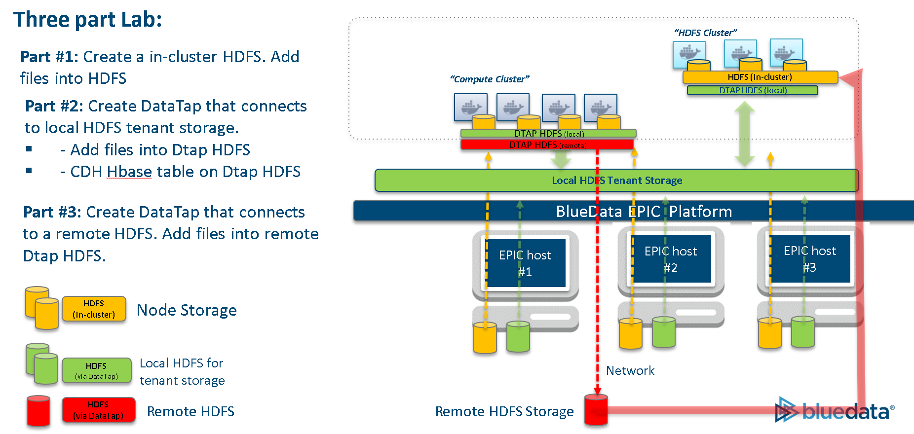

## Task 1a Build and validate in-cluster HDFS

This task 1a will take approximately 30 mins to complete

1. Build and validate in-cluster HDFS

Create a CDH 5.14.2 on 7x with Cloudera Manager Cluster in Demo tenant

Cluster name: CDH-HDFS

3 node cluster:

* One controller (Medium flavor),
* Two workers (Ultra-small flavor))

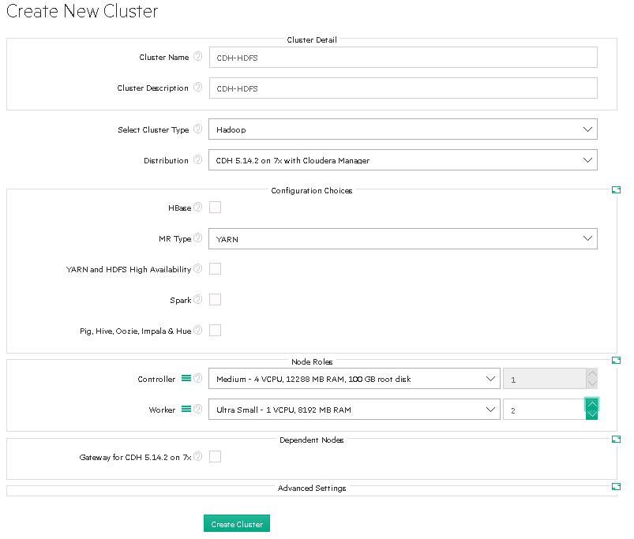

1. Note the IP address of the NameNode: (e.g. 172.18.0.18)

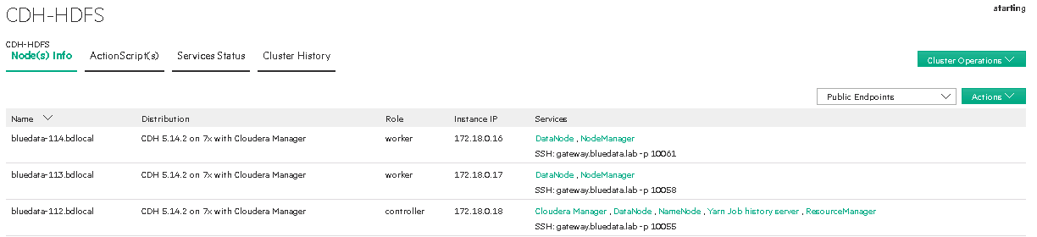

1. Logon to the CDH-HDFS controller container and add file to **hdfs:/** as a hdfs user

[bluedata@bluedata-112 ~]$ **sudo su**

[root@bluedata-112 bluedata]# **su hdfs**

[hdfs@bluedata-112 bluedata]$ **hdfs dfs -ls hdfs:/**

[hdfs@bluedata-112 bluedata]$ **hdfs dfs -copyFromLocal /etc/hosts hdfs:/file1**

[hdfs@bluedata-112 bluedata]$ **hdfs dfs -ls hdfs:/**

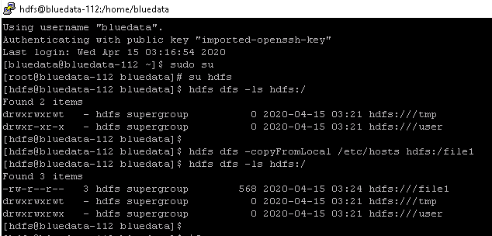

## Task 1b Validate DataTap to local HDFS tenant storage (dtap://TenantStorage)

This task 1b will take 15-30 mins

1. Validate that DataTap functionality has been integrated into CDH cluster

In the CDH-HDFS cluster, go to **Cloudera Manager UI->Clusters->HDFS->Configuration**, type “bluedata” in the search field.

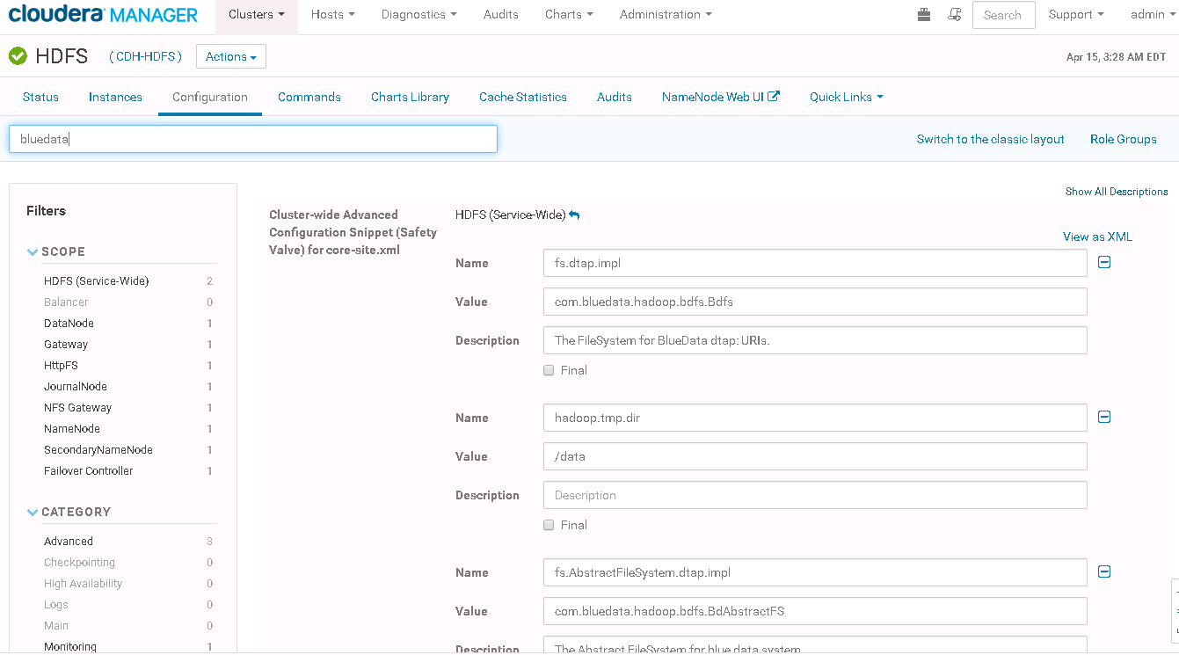

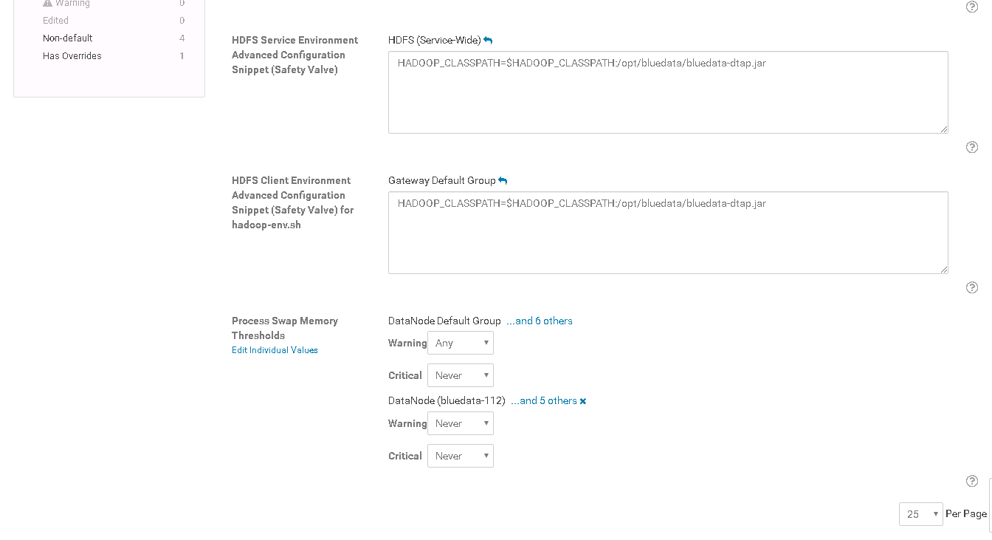

1. On the cluster controller container, look at **/opt/bluedata** and see **bluedata-dtap.jar** file

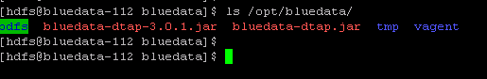

1. Confirm there is local HDFS storage configured for local tenant storage
2. In Demo tenant, browse **dtap://TenantStorage** content via Manage DataTaps.

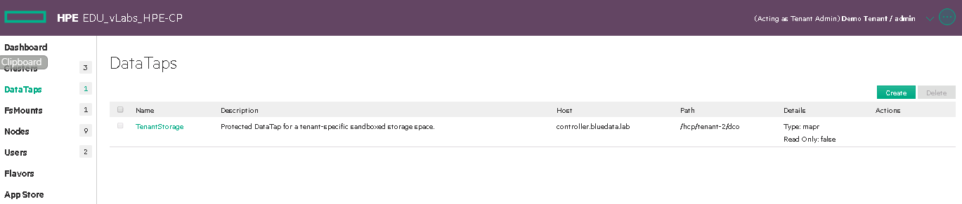

1. Upload a file to the storage. Select File Upload.

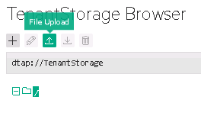

1. Browse the BD_Demo Tenant.pem file from the c:\Downloads and click on Open

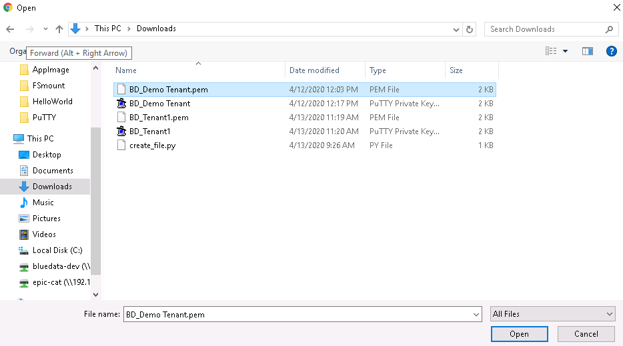

1. Verify that the file has been uploaded

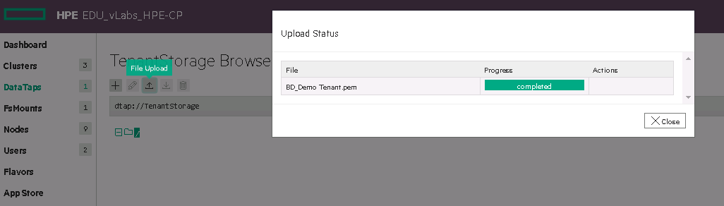

1. On cluster “CDH-HDFS”, check that file uploaded in step #1 exist at **dtap://TenantStorage**.
2. Add file to Dtap TenantStorage as a hdfs user.

[hdfs@bluedata-112 bluedata]$ **hdfs dfs -copyFromLocal /etc/hosts dtap://TenantStorage/file2**

[hdfs@bluedata-112 bluedata]$ **hdfs dfs -ls dtap://TenantStorage/**

1. Observe the newly added file in the TenantStorage Browser (may need to refresh the page).
2. Run a Teragen job

[hdfs@bluedata-112 bluedata]$ **hadoop jar /opt/cloudera/parcels/CDH/jars/hadoop-examples.jar teragen 10000 dtap://TenantStorage/job01**

[hdfs@bluedata-112 bluedata]$ **hdfs dfs -ls dtap://TenantStorage/**

1. Observe the file results in the TenantStorage Browser (may need to refresh the page).

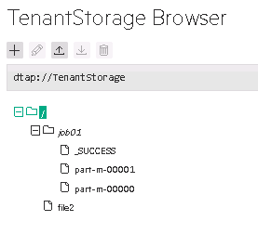

1. Validate Dtap connectivity using Dtap tools on the EPIC host controller. Run the following commands:

[root@controller ~]# **/opt/bluedata/common-install/scripts/tools/checkdtap.sh**

[root@controller ~]# **bdconfig –getdtaps**

[root@controller ~]# **bdconfig –getdtapchecklist**

## Task 1c Configuring CDH HBase with DataTap

This task will take approximately 30 mins to complete

1. Create a CDH 5.14.2 on 7x with Cloudera Manager Cluster with these values.

Cluster name: CDH-HBase

Cluster Type: Hbase

Enable HBase

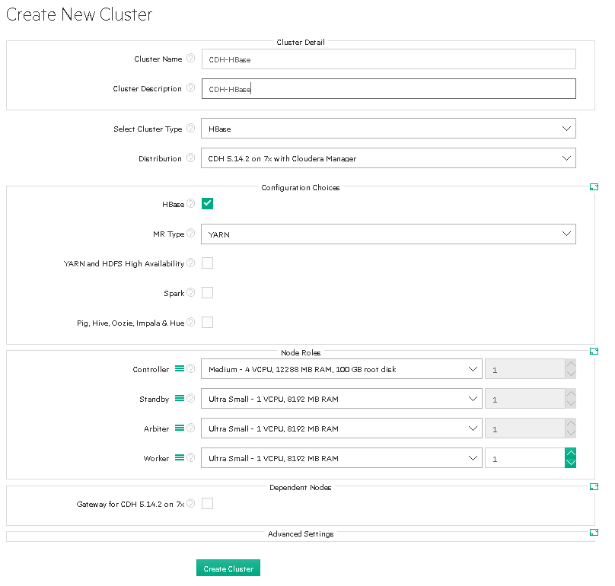

1. Configuring CDH-HBase with TenantStorage DataTap
   1. In the CDH-HBase cluster, go to **Cloudera Manager->Clusters->HBASE->Configuration**.
   2. In HBase **Configuration** screen, type “safety” in the search field
   3. Click on + HBase Service Advanced Configuration Snippet (Safety Valve) for hbase-site.xml
   4. Provide Name: hbase.rootdir and Value: dtap://TenantStorage/hbaseTest

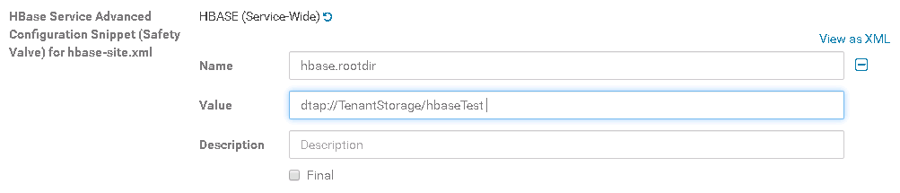

* 1. Next, search for 'staging' and find the hbase.bulkload.staging.dir property. The default value will be /tmp/hbase-staging. Change it to “/hbaseTest/hbase-staging”

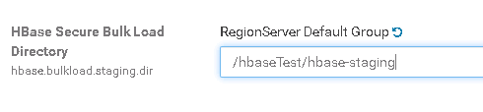

* 1. This will be created as a parallel directory to your hbase.rootdir directory in your TenantStorage datatap as **dtap://TenantStorage/hbaseTest/hbase-staging**.
  2. After you have entered your preferred paths for both the root directory and the staging directory, click the “**Save Changes**” button.
  3. Cloudera Manager will indicate that you have stale configurations and will require that you restart stale services.

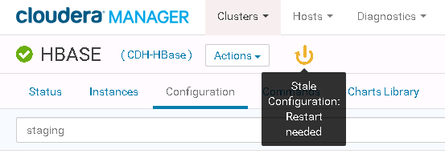

* 1. Click on Restart State Services

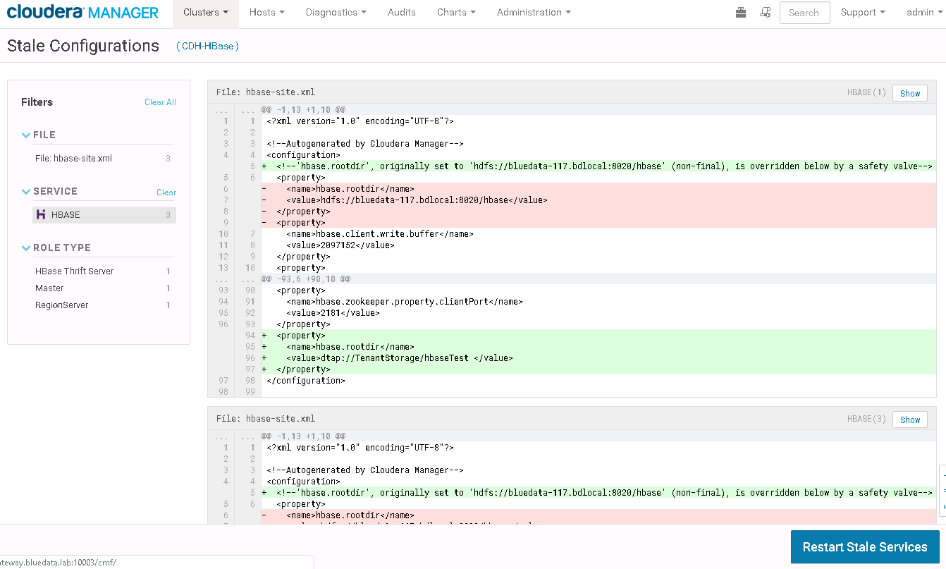

* 1. After restarting the services, go back to your EPIC UI, you will see that your directories have been created.
  2. Delete CDH-HBase cluster

## Task 1d Build and validate DataTap to remote HDFS

This task will take approximately 30 mins to complete

1. Create a CDH 5.14.2 on 7x with Cloudera Manager Cluster with these values.

This cluster will access the remote HDFS.

Cluster name: CDH-Compute

3 node cluster:

* + One controller
  + Two workers

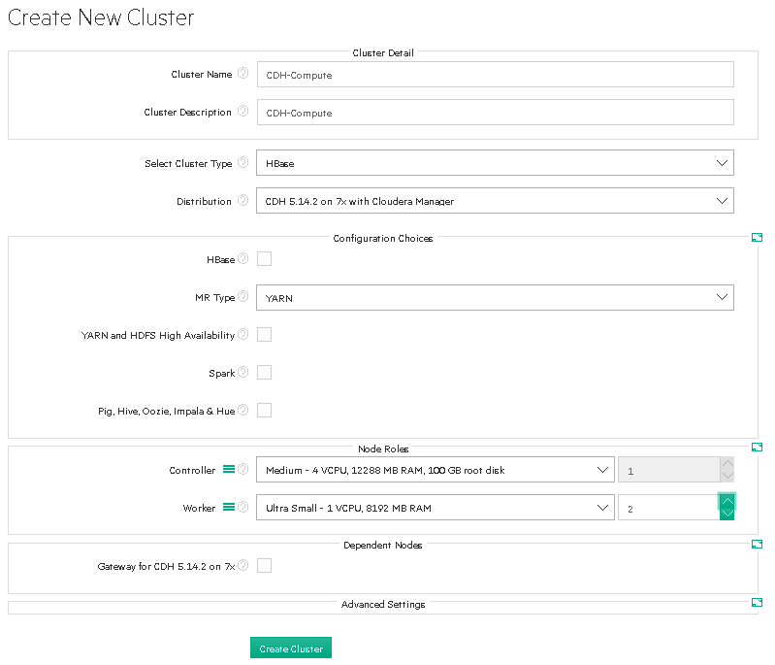

1. Create a DataTap that connects to remote HDFS on cluster “CDH-HDFS”.
   1. Click on DataTaps and click on Create, provide

Name: “DTapRemote”

Host: IP address is obtained from Lab Section “Task 1a: Build and validate in-cluster HDFS” (e.g. 172.18.0.18)

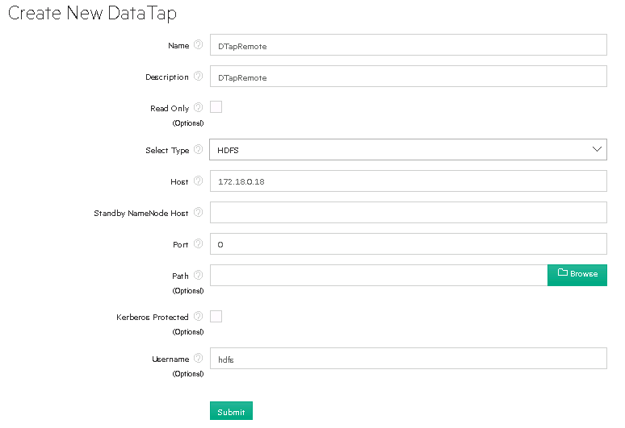

1. Browse DataTap content on EPIC UI.

You should have noticed the content is the same as Lab section 11.

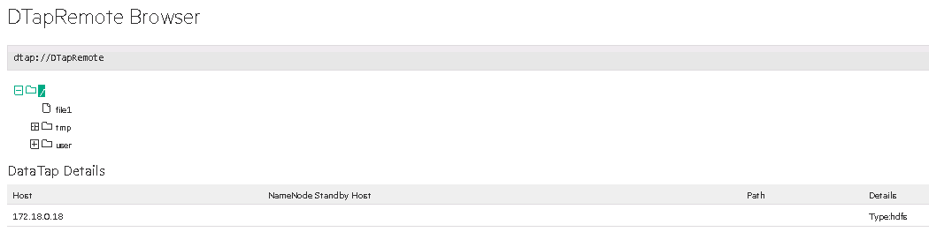

1. Logon to “CDH-Compute” cluster, add files to remote dtap

[bluedata@bluedata-121 ~]$ **sudo su**

[root@bluedata-121 bluedata]# **su hdfs**

[hdfs@bluedata-121 bluedata]$ **hdfs dfs -ls dtap://DTapRemote/**

[hdfs@bluedata-121 bluedata]$ **hdfs dfs -copyFromLocal /etc/hosts dtap://DTapRemote/file2**

[hdfs@bluedata-121 bluedata]$ **hdfs dfs -ls dtap://DTapRemote/**

[hdfs@bluedata-121 bluedata]$ **exit**

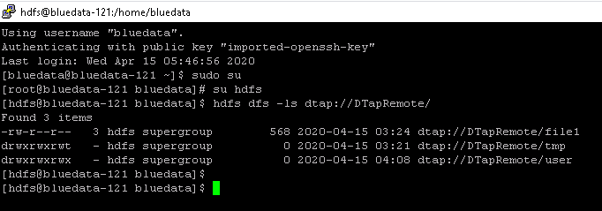

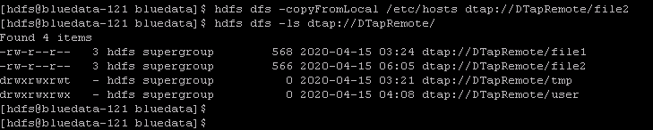

1. Verify the file result in EPIC UI DataTap browse window

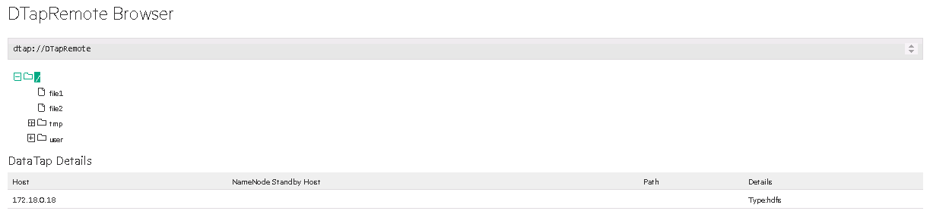

## Task 1e Monitor Dtap activity

**Purpose of lab:**

* Determine which EPIC host is performing Dtap activity. Learn to use EPIC host and node mapping.
* Then monitor Dtap activity by looking at the host: (/var/log/bluedata/bds-cachingnode.log
* This task will take 5-10 mins to complete

1. Use the same container that was used in previous lab where you ran “hdfs dfs -ls dtap://DTapRemote//” command.
2. Logon to the EPIC controller host. Tail the BlueData cachingnode log file:   
   tail –f /var/log/bluedata/bds- cachingnode.log Observe the BlueData activity as you repeat the same the hdfs task on container.
3. On the container, run the command “hdfs dfs -ls dtap://DTapRemote/”

# Task 2 Network

This task will take approximately 30 mins to complete

## Task 2a Validate Network Isolation

**Purpose:**

The purpose of this lab is validate network isolation enforcement between the tenants. This task 2a will take 10-15 mins to complete

1. If not already running, launch 2 clusters (cluster 1 & cluster 2) in Demo Tenant. Launch 1 cluster (cluster 3) in Tenant1.
2. Validate network connectivity between cluster 1 and cluster 2.
   1. Get the IP address of each cluster:
      1. From EPIC UI, look at the cluster status
      2. On each controller container console session in each cluster, run “hostname -i”
   2. Run ping test between cluster 1 and cluster 2.
   3. Run ping test between cluster 1 and cluster 3.
   4. Run “cat /etc/hosts” in each container.
3. Check if you can connect between cluster 1 and cluster 3. Validate that these clusters cannot communicate to each other.
4. Stop all the existing active clusters.
5. Click on Settings under GLOBAL SETTING, click on Network tab
6. Disable Tenant Network Isolation.

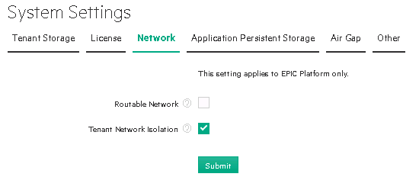

1. Repeat steps 1, 2, and 3. Validate that these clusters is now able to communicate to each other.
2. Stop all the existing active clusters.
3. Enable Tenant Network Isolation.

## Task 2b Multiple browser sessions to multiple virtual clusters on the same application

**Purpose:**

The purpose of this lab is to show the browser “cookie” issue on a non-routable gateway machine. This task will take 10-15 mins

1. Bring up two CDH clusters.
2. On the same browser, have 2 tabs. Each tab logon to Cloudera Manager to each CDH cluster.

What did you observe?

Can you suggest how do we overcome this problem?

Lab Complete